Extra support for people in Tees Valley

Here are a few local and national resources that might help you on your journey. Most of these options are free, but some services (such as gyms) may come with a charge. Just press control on your keyboard and click on the blue links.

Please note that whilst the below resources have been suggested by experts in the Tees Valley, neither Flippin’ Pain nor any of its partners oversee them and therefore cannot guarantee the contents.

Learn about how pain works and how to manage it:

- Flippin’ Pain: an explanation of the science of pain and how it could be relevant to you. Includes the Flippin’ Pain Formula, a free series of podcasts, activities and videos for you to complete in your own time.
- Live Well With Pain: a guide on how to manage your pain that covers topics such as acceptance, pacing, setting goals and managing setbacks, among others.
- Retrain Pain: a number of courses available in 30+ languages. Topics include understanding pain, sleep and pain, medications, relationships, and more.
- Pain Concern: a charity website that has a number of leaflets to download about different conditions, treatments and situations, as well as a podcast that interviews pain specialists and people living with pain.
- The Pain Toolkit: a document outlining practical tips and tools for pain management, developed by Pete Moore who lives with persistent pain himself.

Find ways to move more:

- Making Every Contact Count: conversation starters, advice and links to free groups and tools.
- NHS Fitness Studio: short video workouts for beginners.
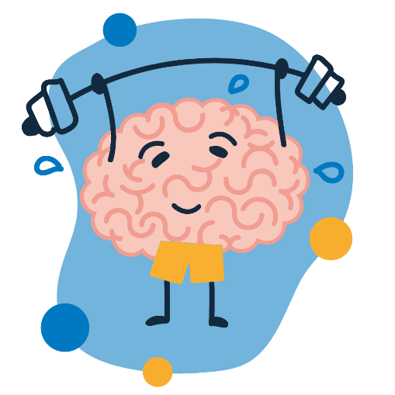
- Chelsea Pain Clinic: a YouTube channel of free Pilates workouts, with playlists on pain education, Acceptance and Commitment Therapy, strength training and more.
- Escape Pain: an app that contains educational and exercise videos for people with long-term hip or knee pain.
- Tees Active: information about getting moving in Stockton.
- Active Hartlepool: information about getting moving in Hartlepool.

Get support for your mental health:
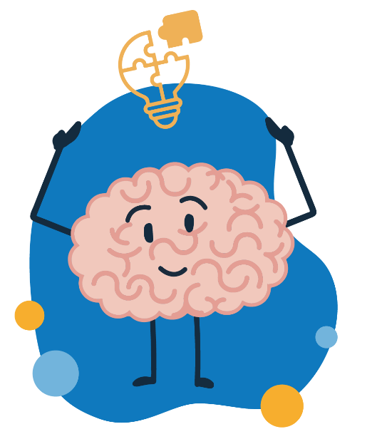
- IMPACT (Improve Lives Across Teesside): support for anyone feeling overly worried, stressed or low. IMPACT offers support in a range of different one-to-one and group settings, and can help with a range of situations, from struggling with long-term pain, to PTSD, to phobias.
- Every Mind Matters: information on reframing unhelpful thoughts and other advice.

Practice relaxation and mindfulness:

- Every Mind Matters: a short introduction to what mindfulness is.
- Calm: a YouTube channel with meditation exercises, soothing noises, advice and much more.
- Insight Timer: a free app featuring meditation, yoga, sleep stories and trackers.
- Progressive muscle relaxation: a written document that guides you through a relaxation technique.

Improve your sleep:

- Pain Concern: a booklet on improving sleep when living with long-term pain.
- Sleep hygiene: a document with lots of tips on getting a good night’s sleep.
- Sleepio: a six-week personalised programme to support insomnia.
- Pzziz: a free app with audio tracks to help sleep.
- The Sleep Charity: information and support around sleep, including a helpline.
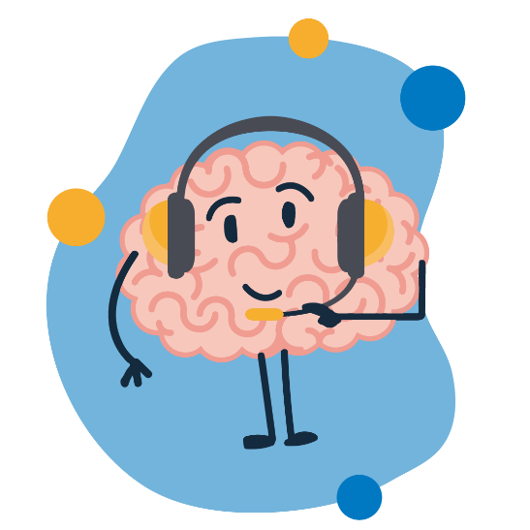

Get support for difficult situations:

- Making Every Contact Count: advice and links to help with many issues including smoking, loneliness, alcohol, housing, finances and more.
- Citizen’s Advice: advice and support available online and in-person across the UK.

Talk to someone who understands:

- Pain Concern: a helpline where someone will get back to you the next working day.
- Versus Arthritis: a helpline open Monday–Friday, 9am–6pm.
- If you’re in crisis: call 0800 0516171 (Durham, Darlington, Teesside & York only).
- Call your GP or visit your nearest Urgent Care Centre.

